Board Bring-Up for Raspberry Pi 4 Model B using Yocto in Linux

BY
Venkatesh A

Table of Contents
1. Introduction 4
2. Hardware Details 4
2.1 Hardware Requirements: 4
2.2 Software Requirements: 4
3. Setting Up the Build Environment 5
3.1 Build Host Packages 5
3.2 Use Git to Clone Poky 5
3.3 Steps to Building Your Image 6
3.4 Examine Your Local Configuration File 6
3.5 Adding the meta-raspberrypi Layer for Yocto 6
4. Building the poky 8
5.Booting up the RPI 9

Figure 1Raspberry Pi 4 Model B board 4
Figure 2 git branch after swtiching to kirkstone 6
Figure 3 cloning the meta-raspberrypi for rpi 4 7
Figure 4 configuring the same branch to meta-raspberry pi 7
Figure 5 Ensure the machine is present 7
Figure 6 Add layer in the poky 8
Figure 7 Checking the Machine 8
Figure 8 bitbake image build 9
Figure 9 Images for the board 9

1. Introduction
This document provides a guide to bringing up the Raspberry Pi 4 Model B (RPI4) using the Yocto Project, a powerful and flexible open-source framework for creating customized Linux distributions for embedded systems. The Yocto Project is commonly used in industries where you need fine-grained control over the software stack, including kernel, bootloader, libraries, and applications.

2. Hardware Details
Raspberry Pi 4 Model B features a high-performance 64-bit quad-core processor, dual-display support at resolutions up to 4K via a pair of micro-HDMI ports, hardware video decode at up to 4Kp60, up to 8GB of RAM, dual-band 2.4/5.0 GHz wireless LAN, Bluetooth 5.0, Gigabit Ethernet, USB 3.0, and PoE capability (via a separate PoE HAT add-on). For the end user, Raspberry Pi 4 Model B provides desktop performance comparable to entry-level x86 PC systems
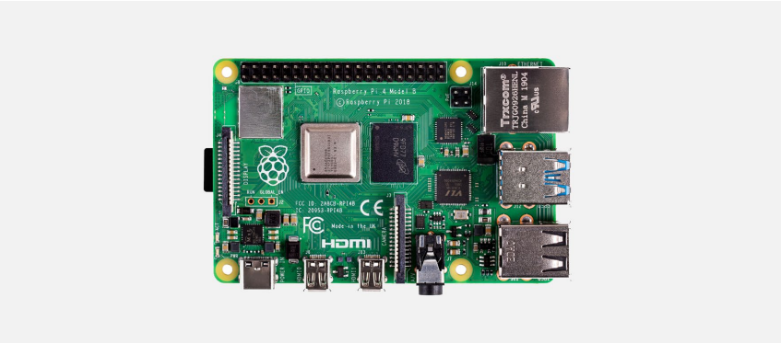
Figure 1 Raspberry Pi 4 Model B board

2.1 Hardware Requirements:
- Raspberry Pi 4 Model B board.
- A microSD card (at least 8GB) for the Raspberry Pi.
- USB keyboard and mouse (for initial setup).
- HDMI cable and monitor (for display output).
- Power supply for the Raspberry Pi (5V 3A recommended).
- Network connectivity (Ethernet or Wi-Fi).

2.2 Software Requirements:
- A Linux-based host machine (Ubuntu or similar distribution recommended).
- Git and repo tool installed on the host machine.

3. Setting Up the Build Environment
This link can be followed, and the steps mentioned below should be followed by the user accessing this document, depending on their choice:
Yocto Project Quick Build — The Yocto Project ® 4.0.23 documentation
Ensure that the following tools are installed on the host machine:
- Git 1.8.3.1 or greater
- Tar 1.28 or greater
- Python 3.6.0 or greater
- GCC 7.5 or greater
- GNU Make 4.0 or greater

3.1 Build Host Packages
You must install the essential host packages on your build host. To install these packages on an Ubuntu-based distribution, run the following command:
$ sudo apt install gawk wget git diffstat unzip texinfo gcc build-essential chrpath socat cpio python3 python3-pip python3-pexpect xz-utils debianutils iputils-ping python3-git python3-jinja2 python3-subunit zstd liblz4-tool file locales libacl1
$ sudo locale-gen en_US.UTF-8

3.2 Use Git to Clone Poky
Once you complete the setup instructions for your machine, you need to get a copy of the Poky repository on your build host. Use the following commands to clone the Poky repository.
$ git clone git://git.yoctoproject.org/poky
Go to Releases wiki page and choose a release codename (such as kirkstone), corresponding to either the latest stable release or a Long Term Support release. Then move to the poky directory and look at existing branches:
$ cd poky
$ git branch -a
For this example, check out the kirkstone branch based on the Kirkstone release:
$ git checkout -t origin/kirkstone -b my-kirkstone
Branch 'my-kirkstone' set up to track remote branch 'kirkstone' from 'origin'.
Switched to a new branch 'my-kirkstone'
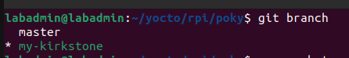
Figure 2 git branch after swtiching to kirkstone
The previous Git checkout command creates a local branch named my-kirkstone. The files available to you in that branch exactly match the repository’s files in the kirkstone release branch.
Note that you can regularly type the following command in the same directory to keep your local files in sync with the release branch:
$ git pull

3.3 Steps to Building Your Image
Use the following steps to build your image. The build process creates an entire Linux distribution, including the toolchain, from source.Initialize the Build Environment: From within the poky directory, run the oe-init-build-env environment setup script to define Yocto Project’s build environment on your build host.
$ cd poky
$ source oe-init-build-env

3.4 Examine Your Local Configuration File
When you set up the build environment, a local configuration file named local.conf becomes available in the conf subdirectory of the Build Directory. Depending on the machine specified in the local.conf file, Yocto will build the corresponding images.
Path: build/local.conf file

3.5 Adding the meta-raspberrypi Layer for Yocto
To build Yocto for the Raspberry Pi 4 Model B, you need to include the meta-raspberrypi layer in Yocto and then build the project. The steps are as follows:
- First, go to the https://layers.openembedded.org/layerindex/branch/master/layers/ website.
- Select the "Layers" option and search for "raspberry pi."
- Review the description to see which boards are supported by the layer.
- Select the appropriate layer and clone it is using Git. By default, it will be on the master branch.
- Change to the corresponding Yocto branch that you have configured.
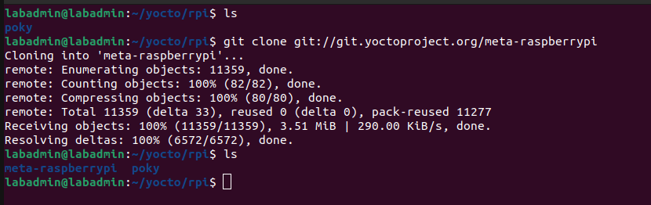
Figure 3 cloning the meta-raspberrypi for rpi 4
To clone the meta-raspberrypi layer from the layers.openembedded repository, follow the standard cloning procedure. After cloning, make sure that the meta-raspberrypi layer is checked out to the same branch as the poky branch to ensure compatibility. This alignment between branches is crucial for the correct integration of the layers. Please refer to the figure below for further clarification
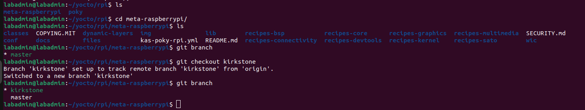
Figure 4 configuring the same branch to meta-raspberry pi
Check if the machine you intend to build for Yocto is available in the cloned meta-raspberrypi layer. The machine configuration files are located in the conf/machine directory, where you will find .conf files for different sets of machines. Please ensure that the correct machine configuration is selected. For your reference, see the figure below.
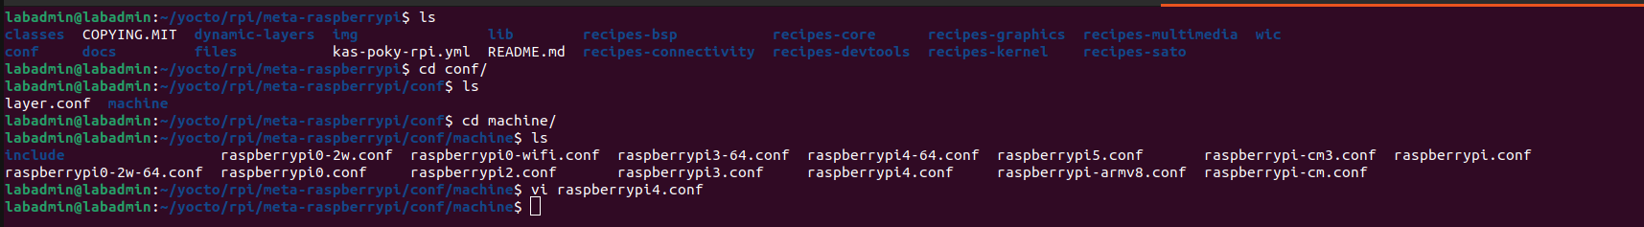
Figure 5 Ensure the machine is present
Check the layers in the poky environment to ensure that all necessary layers are present. If any user layers are missing from the current poky environment, add them using the appropriate bitbake commands. For your reference, please see the figure below.
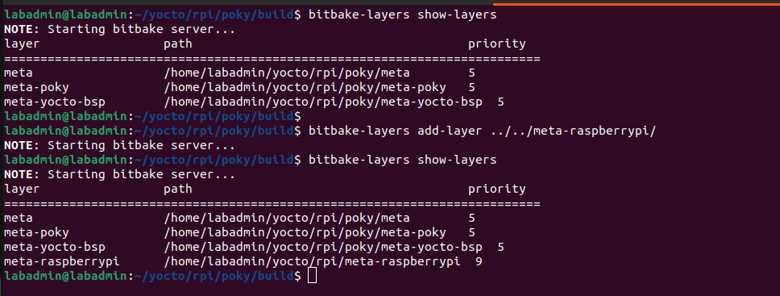
Figure 6 Add layer in the poky
After adding the layers, the user needs to modify the local.conf file located in build/conf/local.conf. Follow these steps:
- Open the local.conf file.
- Comment out the existing machine configuration.
- Add the following line: MACHINE = "raspberrypi4".
- On the next line, add: INHERIT += "rm_work".
- Save the file.
Finally, ensure that the correct machine is selected for the build by running the appropriate bitbake command. For reference, please check the figure below.
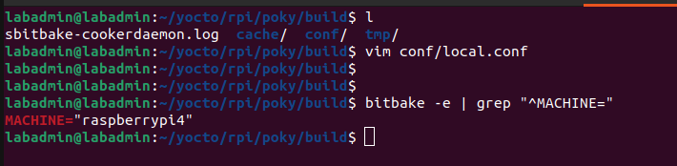
Figure 7 Checking the Machine

4. Building the poky
After configuring all the details in the local.conf file, you can begin building the poky environment using the bitbake command:
bitbake core-image-minimal
The build process may take some time, so please ensure that the host machine is connected to a stable and high-speed internet connection. For reference, please see the figure below.
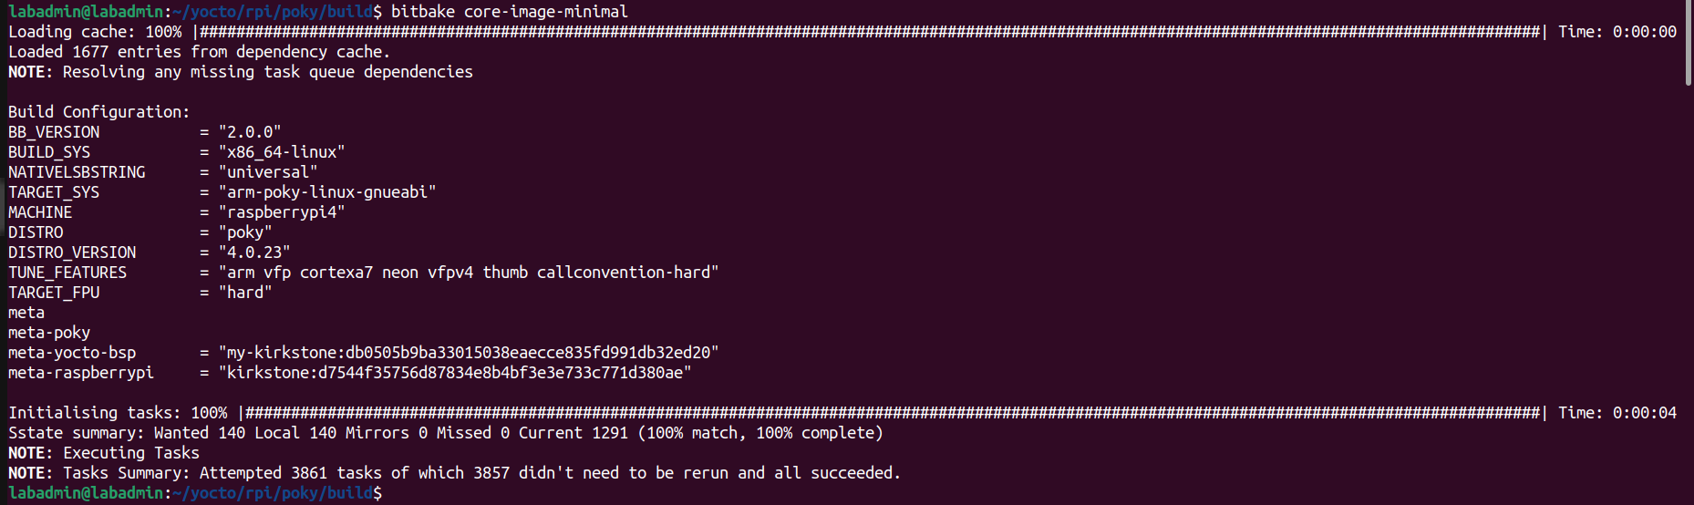
Figure 8 bitbake image build
After building the poky environment, the generated images will be located in the build/tmp/deploy/images/<Machine_name> directory. In this path, all the necessary images will be available. Please ensure that you copy all required images to the SD card and verify that it is bootable.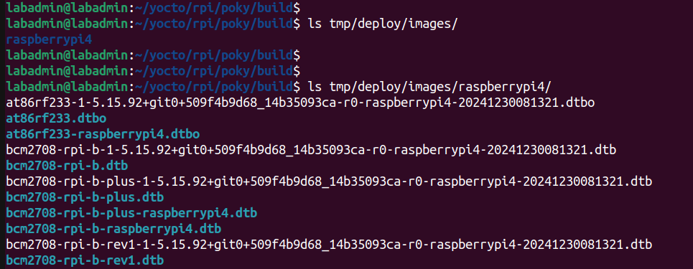
Figure 9 Images for the board

5.Booting up the RPI
Once the images have been successfully copied to the SD card, insert the SD card into the Raspberry Pi 4 Model B. Connect the Raspberry Pi board to the power supply and a monitor. The booting process will begin, and the Raspberry Pi board will start running the Yocto build images. For reference, I have attached images below. Please check the figures.
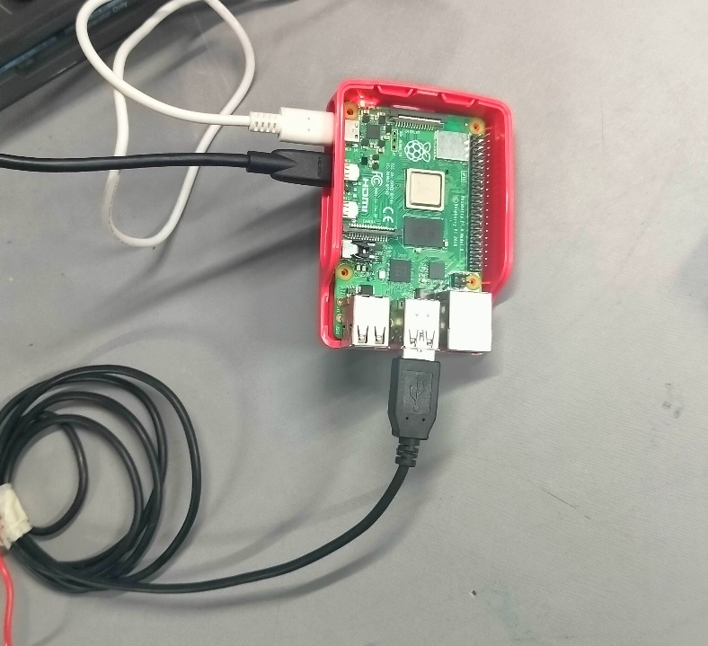
Figure 10 Raspberry pi board setup
Once the board has booted up, the images should appear as shown below. Please find the attached figure for reference.
